**CHAPTER THREE: SYSTEM ANALYSIS, DESIGN AND IMPLEMENTATION**

**3.0 METHODOLOGY**

French (1996) defined data collection as “the process involved in getting data from its point of origin to the computer in form suitable for processing”. There are many techniques or methods of collecting facts or data which may be employed. For this particular task, there are two methods of data capture used to gather facts about the nature and operation of the existing system.

**3.1 METHODS OF DATA CAPTURE**

* Primary Method
* Secondary Method

**3.1.1 PRIMARY METHOD**

This is achieved by the means of the following:

* **Interview:** this method is used to collect information verbally through some questions passed by the interviewer. Interview is a form of conversation rather than interrogation by discussing system characteristics with carefully selected respondents who may be staffs or personnel who are current users of the existing system.
* **Direct observation:** this process entails the researcher, getting the information sought for by directly observing the nature and manner of carrying out operations in the organization. The advantages of this method of data collection include accuracy and efficiency of the data collected.

**3.1.2 SECONDARY METHOD**

This is the investigation of existing system by means of “Record inspection”. This section gives the highlight of the fact collected about the mode of operation of the existing system, mode of their record keeping, some documents about the organization (IN THIS CASE OPERATIONS IN GUARANTY TRUST BANK WILL BE CONSIDERED) consisting of booking of cash deposits, cash withdrawal, treasury operations like cashing in and out of vault were properly scrutinized and studied. Some of the records are shown below;

**3.2 SYSTEM ANALYSIS**

The analysis phase of this project is aimed to understand the nature, characteristics and problems peculiar to the existing system. This understanding of the system involves collection and analysis of facts about the mode of operation of the existing system. As stated earlier, the aim of this analysis is to figure out the problems of the existing system and consequently provide solutions to such problems. To achieve this the facts collected were studied and then compared with the standards expected of the Cash Handling Mechanism. Much more in this era of computer technological advancement. It was discovered that the manual system is below standards. The following problems were noted.

* Ineffective information storage and retrieval.
* Improper keeping of large volume of records.
* Improper handling of management functions.
* Cash analysis calculation is slow and tedious.
* Lack of trained and skilled employee as staff.

The objectives or aim of the proposed system is to curtail the process observed with the manual system which has earlier been emphasized. The expected benefits that would accrue from the proposed system is that the hassles experienced in the management system will be greatly reduced if not completely eliminated. This will lead to efficiency, forecasting, fast decision making and effective information being available when needed or required.

Furthermore, the following are other benefits that could also be derived from the proposed system:

* Fast entry of cash analysis.
* Keeping of large volume of records.
* Maintaining a high level of management, data integrity and information security.

3.3 **DESIGN PHASE**

Design phase in the development of this software is aimed at developing the technical details of the proposed system and designing the structure of the input and output. In this design of the system application program there is need to put the hardware capacity into consideration, which also takes detailed collection of various variables which covers all input record of data information about the particular case study (IN THIS CASE OPERATIONS IN GUARANTY TRUST BANK WILL BE CONSIDERED) that will provide a process out of a required functional system specification. A new system is designed by only authorized personnel. At the beginning of the program, the user is asked the particular operation intended to be performed ranging from the options in the main menu.

**3.4 THE INPUT DESIGN**

In this section of design, adequate care and accuracy is taken to design the screen layout. The most sensitive and essential part is the preparation and collection of all forms of input files in the applied case study (IN THIS CASE, OPERATIONS IN GUARANTY TRUST BANK WILL BE CONSIDERED). Records and files are channeled together for an input entry into a data bank. This is very important aspect of describing the logical order, on how data are arranged and organized during the program design. This shows how the required data are arrange in an organized data format: -

**THE INPUT FORMS**

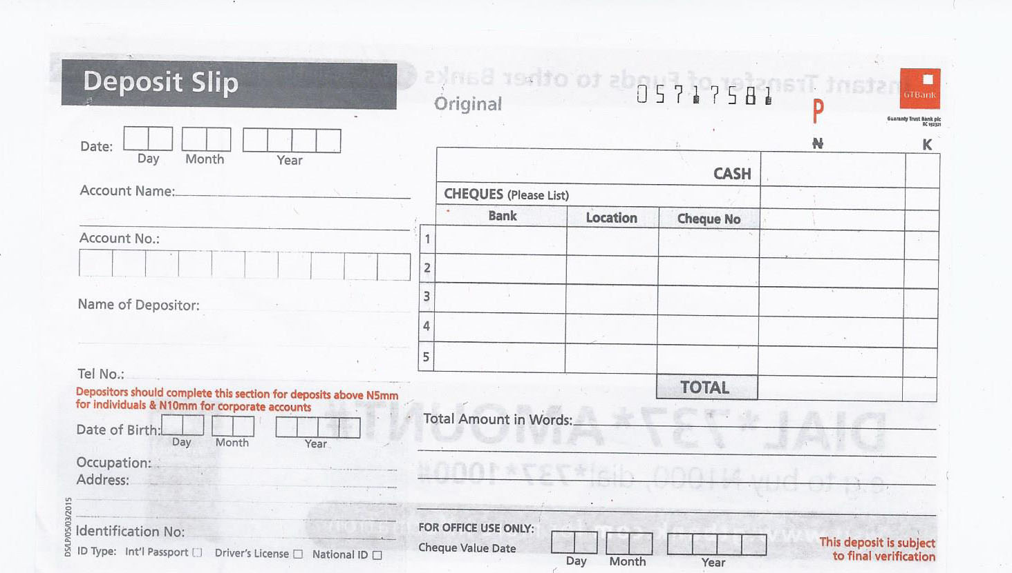

**1a. DEPOSIT SLIP**

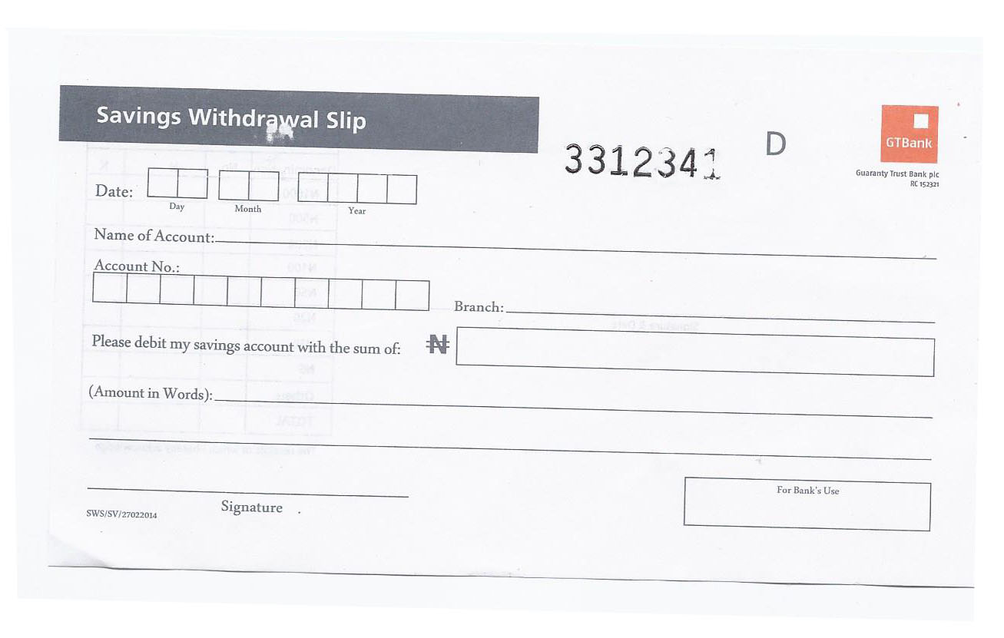

**1b. WITHDRAWAL SLIP (front view)**

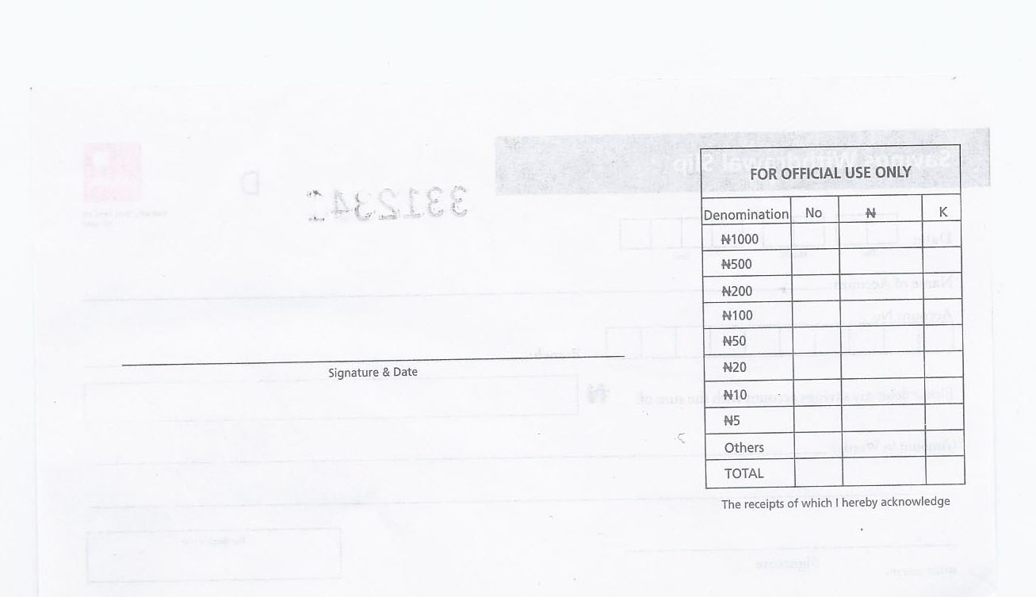

**1c. WITHDRAWAL (back)**

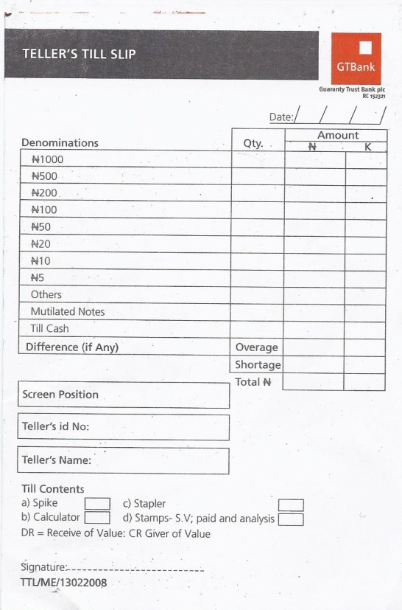

**1d. TILL SLIP**

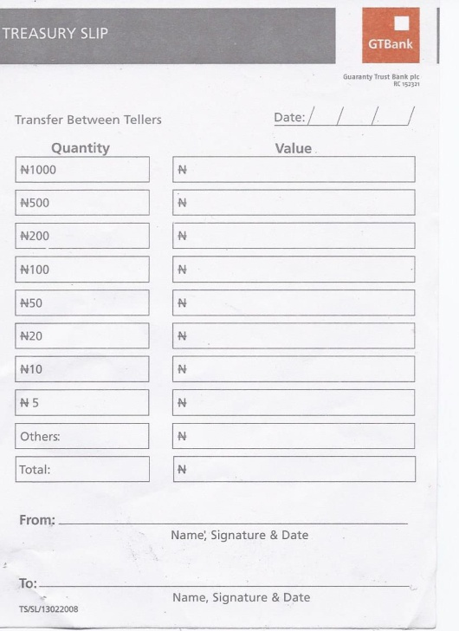

**1e. TREASURY SLIP**

**3.5 THE OUTPUT DESIGN**

This refers to any information that is produced by the system whether printed, displayed on the screen or spoken. The following below are some of the list of output design. They are mainly reports generated for staff.

They are:-

* The total for analysis of each denomination entered.
* The overall total for the combined analysis for every denominations presented by a customer.
* Pictures of major world currencies.
* The shortage or overage i.e. in other terms the amount to be added by the customer or the change to be returned to the customer after the system compare the overall total with the amount on the instrument used for transaction. This could either be a teller or an invoice as the case may be.

The softcopy output to be displayed on the screen for analysis and information to be obtained on each transaction.

**THE OUTPUT REPORT/ FORM**

**3.6 SYSTEM BLOCK DIAGRAM**

**MAIN MENU PROGRAM MODULE**

**(MUTIPLE CHOICE)**

**ADMINISTRATOR TICKET BOOKING**

**SUBPROGRAM SUBPROGRAM SUBPROGRAM MODULE**

**PROGRAM MODULES SPECIFICATION**

**MODULE FUNCTIONS**

**MAIN MENU** This module provides the user with variouschoices of procedures to be performed by the system.

**PASSWORD VEIFICATION** This module is a program that enforces security and prevents an unauthorized user access to the system.

**ADMINISTRATOR** This sub-program allows the company management to specify the number of vehicles ready for journey for the day’s transactions.

**TICKET BOOKING** This sub-program is used by the user to input passengers details.

**VIEW RECORD** This sub-program allows records in the system to be viewed for analysis and equally shows the user the manifest of travelers and their respective vehicle details.

**EXIT MENU** This module takes the user out of the program entirely.

* 1. **SYSTEM REQUIREMENTS**

The System Requirement involves the following:-

* The Hardware Requirement
* The Software Requirement
  + 1. **HARDWARE REQUIREMENTS**

**The** hardware is the physical component of the computer system. They are the unintelligent part, which needs software such as the program being designed in order for it to junction. The minimum hardware requirements required in the implementation of the system includes:-

* A Pentium II of 500 MHZ processor and above.
* HDD capacity of 40 GB.
* 128 MB RAM
* Other peripherals like mouse, keyboard, 64 Bit Capacity Visual Display Unit, webcam if available or a digital camera can be used.
* A printer.
  + 1. **THE SOFTWARE REQUIREMENT**

Software is a set of instructions that allow the hardware to function. Software is the intelligent part which controls the hardware and how the hardware interacts with each other. The software used in the design and implementation of the proposed system includes:-

* A Window based operating system (versions from WIN 98 and above).
* Visual Basic Programming Language
* MS Office installed on the system most especially MS ACCESS.

**3.8 IMPLEMENTATION PHASE**

The implementation phase includes all the processes assuring that the information system is operational and making sure that user takes its operation for use and evaluation. The implementation activities involve all that takes place to transform the system design and system specification to the program codes and the actual conversion from the old system to the newly developed one.

The employed approach to the implementation of the Transportation Firm Management System (TFMS) is choosing a conversion strategy.

The next approach is to evaluate or modify the information system, performing measures on which to evaluate the new system are crucial to well functioning of the system result/reports. Need fully, evaluations are taken from personnel to even users, managements and even analysts.

The final step to the implementation of Transportation Firm Management System is using different strategy for training users, and information personnel taking them on their own level, using a verify of training techniques, making sure that each user understands the new role that they must enact because of the new system.

However, the objectives of the implementation are to ensure that the system perform as required by the specification, this project can be implemented at YANKARI TRANSPORT COMPANY BAUCHI.

The Result obtained during the system implementation are displayed on the screen and printed are attached in the appendix containing some of the output of the system which were printed. The output is mainly report generated for the management decision making. The report generated is as discussed in the output design section (Section 3.5).

**CHAPTER FOUR: SUMMARY, RECOMMENDATION AND CONCLUSION**

**4.0 SUMMARY**

The aim of developing this system is to help the transport organization with the difficulties experienced in data collection compilation, processing, generation of records and calculation and also data integrity and information security. The limitations experienced in manual system of carrying out operations led to the need for computerizations of operations. The benefits achieved in a computerized system can not be over emphasized .YANKARI MOTOR TRNSPORT, since its start of operation has been faced with many problems ranging from poor documentation of its sales record, unaccountable sales, fraud etc which arose due to the manual mode of operation. The project has attempted to introduce a computerized means of operation via the provision of a computer program written in visual basic programming language, where all the input required and the possible output have been specified.

This work also contains some programming terms and it also provides information on the necessary requirement needed for the program (new system) to be properly implemented.

* 1. **CONCLUSION**

In conclusion, when looking at the improvement, efficiency and quickly service that can be derived from the system, one can conclude that it out weighs the manual methods of passengers record keeping. Transportation Firm Management System (TFMS),has been developed to exploit the terrific power of computer technology having found out that the traditional filling system is the most inadequate in record keeping system of the transport company. As a result of TFMS development decision about improving on the services rendered to passengers/costumers could be assisted by the provision of necessary information concerning any costumers/staff either by view of records or generation of report.

**4.2 RECOMMENDATION**

With the opportunities and advantages the computer system offers, embarking on this is worthwhile, bearing in mind the challenges which can be overcome using the new system. Therefore, the automaton of the operations of services rendered to costumers should be embraced by the transport company.

Based on the fact the aim of this project is, it is recommended that:-

* Organization and Firms should make use of computer in its operations so as to make it services effective and increase its profit making capacity.
* Support should be made by the management of YANKARI TRANSPORT COMPANY to buy more computers because of the computer technology era and as the world is becoming a “global village.”
* Finally, to handle the system itself requires a higher degree of expertise therefore, a computer scientist or a well trained and experienced person should be put in charge of the system as Database Administrator. Hence integration of the training and manpower development activities with the system is highly recommended.

**REFERENCES**

Thompson T. Handabourg (2001), Oxford Advanced Learner Dictionary, special price edition publisher.

Ewing T.A. and Reid F. Dickson (1982). **Measuring Transportation Performance.** Transportation Quarterly.

Gordon Ernest R. and Bullock Phil (1997). **Putting Transportation Investments in Context.** Transportation Quarterly.

David Aniobi (2010). **Management Information System.** Computer Science Department**,** Federal Polytechnic Bauchi.

Hoch L. Clinton (1998). **Find the Best Ways to Your Market.** Transportation and Distribution.

Mr. Umoh N. (2010) **Seminar Report on Project.** Computer Science Department, Federal Polytechnic Bauchi.

Weiss Howard J., Allyn, Bacon, Mark E. Gershon (1989). **Production and Operations Management.** Bullock Team, Australia.

Stephen A. Oklo (2009). **Automated School Management System.** Federal Polytechnic Bauchi.

Effiong Daniel (2009). **Computerized Customers Booking System.** Federal Polytechnic Bauchi.